ADITHYA R
192311369

10.Create a Cloning of a VM and Test it by loading the Previous Version/Cloned VM using virtualbox.
AIM: To create a clone of a virtual machine in VirtualBox and test it by running the cloned VM or restoring the previous version.
PROCEDURE:
*Open VirtualBox and select the virtual machine you want to clone.
*Right-click the VM and select Clone.
*Enter a name for the cloned VM and choose Full Clone or Linked Clone, then click Next/Clone.
*Once cloning is complete, start the cloned VM to verify it runs independently.
*Optionally, make changes in the cloned VM and restore the original VM to its previous state to test functionality.

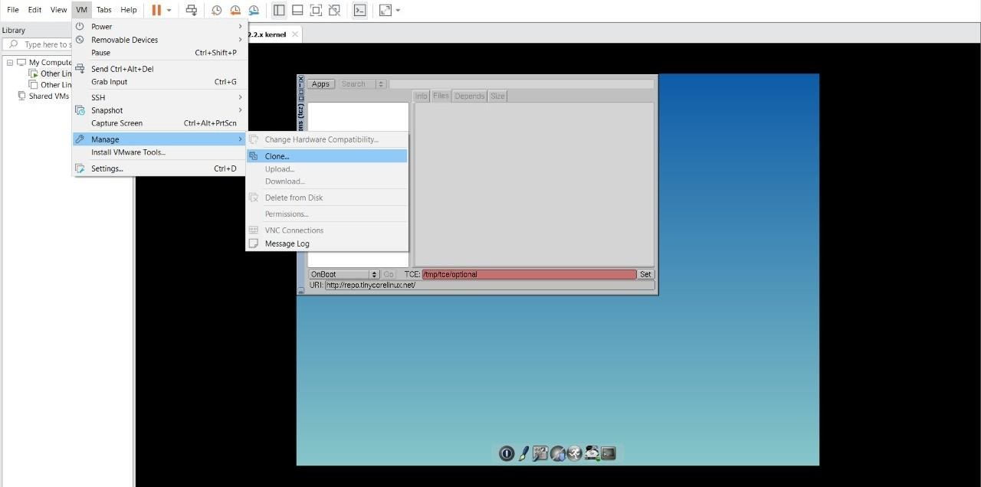

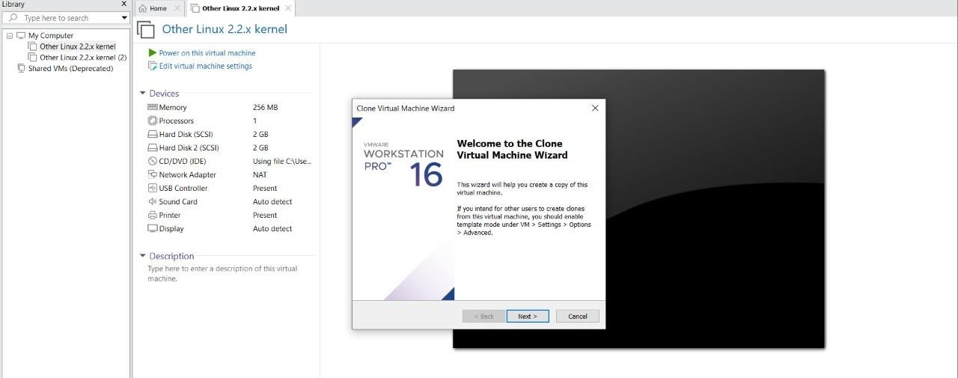
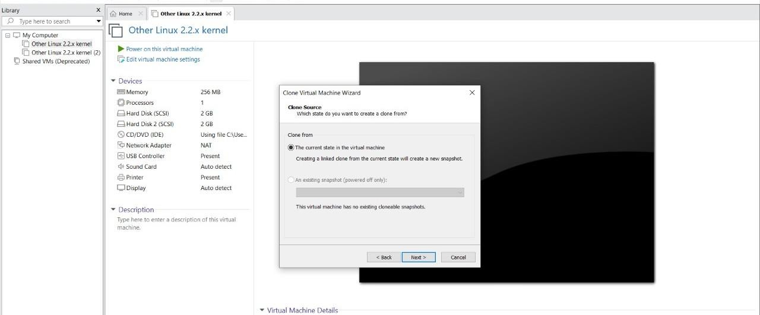
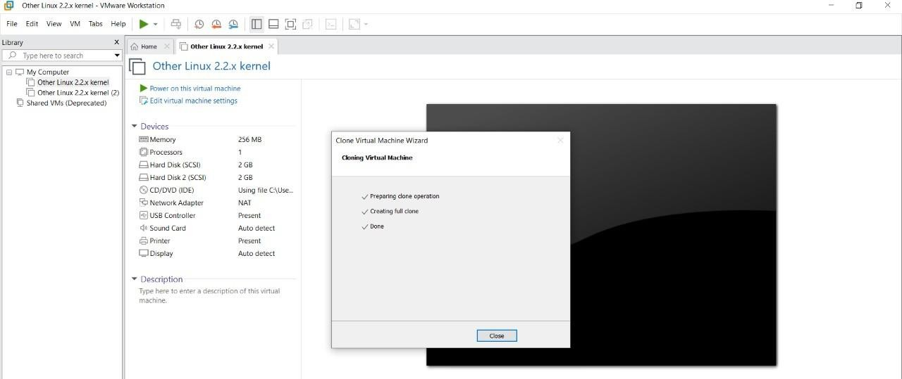
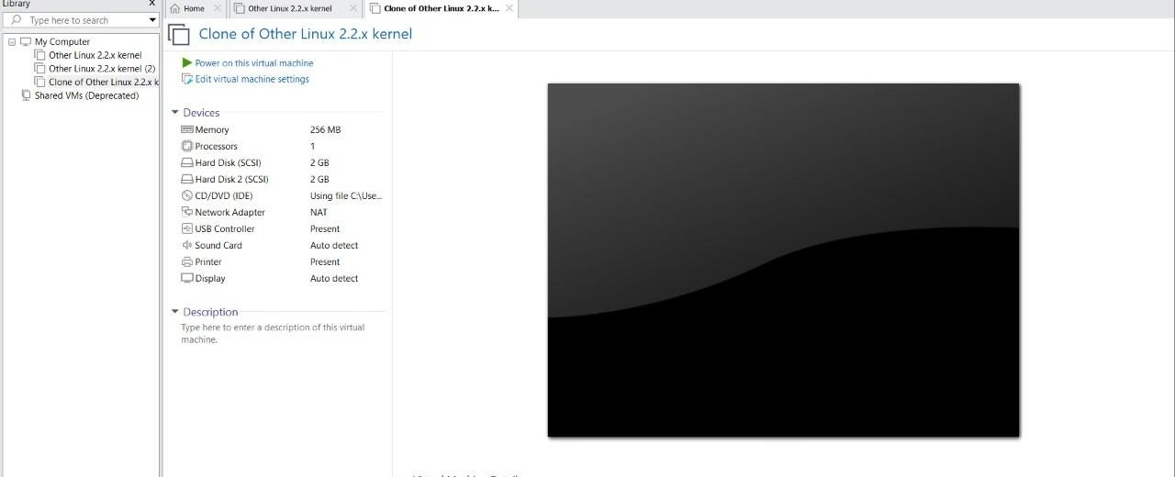

RESULT:
- The virtual machine is successfully cloned.
- The cloned VM runs independently with the same configuration as the original VM.
- Restoring the original VM to a previous version confirms the clone is separate and that snapshots or previous states are preserved.

